**Year 1**



**BSc (Hons) in Information Technology**



**Tutorial 5**

**IT1010**  **– Introduction to Programming** **Semester 1, 2020**

**Question 1**

What is the output of the following statements?

1. printf( “%.2f\n”, 3.446);

Output = 3.45

1. printf(“%.1f\n”, 3.446);

Output = 3.4

**Question 2**

Write statements to,

1. Print the value 123.4567 with 2 digits precision.

printf( “%.2f\n”, 123.4567);

1. Print the value 3.14159 with three digits to the right of the decimal point.

printf( “%.3f\n”, 3.14159);

1. Print the value 333.546372 in a field width of 15 characters with precisions of 1,2,3,4 and 5.

printf( “%.15f\n”, 333.546372);

printf("%.1f\n",333.546372);

printf("%.2f\n",333.546372);

printf("%.3f\n",333.546372);

printf("%.4f\n",333.546372);

printf("%.5f\n",333.546372);

**Question 3**

Draw a flow chart to enter the radius of a circle from the keyboard and display the diameter, the circumference and the area.

Convert the above flow chart into a C program.

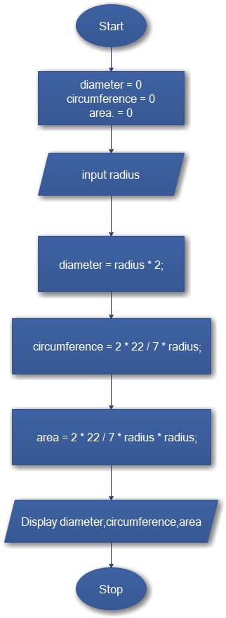

#include <stdio.h>  
  
*int* main(*void*) {  
 *float* radius;  
 *float* diameter;  
 *float* circumference;  
 *float* area;  
  
 printf("Input the radius : ");  
 scanf("%f", &radius);  
  
*// find diameter;* diameter = radius * 2;  
  
 printf("\bDiameter is : %.2f\n", diameter);  
  
*// find area* circumference = 2 * 22 / 7 * radius;  
  
 printf("\bArea is : %.2f", circumference);  
  
*// find circumference* area = 2 * 22 / 7 * radius * radius;  
  
 printf("\nCircumference is : %.2f", area);  
  
 *return* 0;  
}

**Question 4**

Draw a flow chart to enter the time duration of an event in seconds and display the hrs, minutes and seconds of the duration separately.

Hours = hr

Minutes = min

Seconds = s

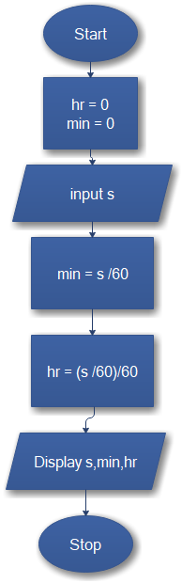

**Additional Exercises**

**Question 1**

a) What does the following print? Assume x = 2 and y = 3.

1. printf( “*\n**\n***\n****\n*****\n” );

Output = *

**

***

****

*****

1. printf( “%d”, x + x );

Output = 4

1. printf( “x = “);

Output = x =

1. printf( “x=%d”, x);

Output = x=2

1. printf( “%d = %d”, x+y, y+x);

Output = 5 = 5

1. /* printf( “%d”, x+y ); */

Output = Nothing print because it is a multi-line comment

1. printf(“\n”);

Output = print a new line.

1. float z = 45.567; printf(“value is %.2f”, z);

Output = value is 45.57

**Question 2**

To travel from home to SLIIT Campus, a particular student needs to take three buses. Draw a flow chart to input the fares of each bus and estimate the traveling expenditure of the student for the entire semester.

Convert the above flow chart into a C program.

(Assume that there are 5 days per week and 13 weeks for the semester).

entire semester = eSFares

Number of count = count

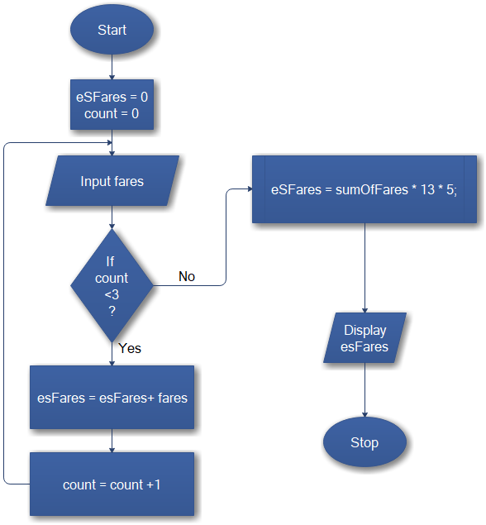

#include <stdio.h>  
  
*int* main(*void*) {  
 *float* fares01;  
 *float* fares02;  
 *float* fares03;  
 *float* sumOfFares;  
 *float* eSFares;  
  
 printf("Input fares of Bus 01 :");  
 scanf("%f", &fares01);  
 printf("Input fares of Bus 02 :");  
 scanf("%f", &fares02);  
 printf("Input fares of Bus 03 :");  
 scanf("%f", &fares03);  
  
 sumOfFares = fares01 + fares02 + fares03;  
  
 eSFares = sumOfFares * 13 * 5;  
  
 printf("Traveling expenditure of the student \nfor the entire semester : %f", eSFares);  
  
}

**Question** 3

The simple interest on a loan is calculated by the formula

interest = principal * rate * days / 365

The preceding formula assumes that rate is the annual interest rate, and therefore includes the division by 365 (days). Develop a program that will input principal ,rate and days for several loans, and will calculate and display the simple interest for each loan

#include <stdio.h>  
  
*int* main(*void*) {  
 *float* interest;  
 *float* principal;  
 *float* rate;  
 *int* days;  
  
 printf("Input Principal :");  
 scanf("%f", &principal);  
  
 printf("\nInput rate :");  
 scanf("%f", &rate);  
  
 printf("\nInput Days :");  
 scanf("%i", &days);  
  
 interest = principal * rate / 100 * days / 365;  
  
 printf("\nSimple interest is : %f", interest);  
  
 *return* 0;  
}

**Question 4**

The Body Mass Index (BMI) is given by



Create a BMI calculator application that reads the user’s weight then calculates and displays the user’s body mass index.

#include <stdio.h>  
  
*int* main(*void*) { *float* weight;  
 *float* BMI;  
 *float* height;  
  
 printf("Input Weight :");  
 scanf("%f", &weight);  
  
 printf("Input Height with meters :");  
 scanf("%f", &height);  
  
 BMI = weight / height * height;  
  
 printf("Your Body Mass Index is : %.2f", BMI);  
  
 *return* 0;  
}

**Question 5**

Write a C program to find the sum of series 1+2+3+4+..+n using the following formula. The program should take the value of n from the key board.

Sum = n * (n+1) * (1/2)

#include <stdio.h>  
  
*int* main(*void*) { *int* n;  
 *int* sum;  
  
 printf("Input Value :");  
 scanf("%i", &n);  
  
 *for* (*int* i = 1; i <= *sizeof*(n); ++i) {  
 sum = n * (n + 1) * 0.5;  
 printf("%i+", i);  
 }  
 printf("\b\nsum of series is : %i", sum);  
  
 *return* 0;  
}

**Question 6**

Write a program that inputs one five-digit number, separates the number into its individual digits and prints the digits separated from one another.

Ex: if user types, 42139, the program should print 4 2 1 3 9

#include <stdio.h>  
  
*int* main(*void*) { *char* dNumber[5];  
  
 printf("Inputs one five-digit number :");  
 scanf("%c", dNumber);  
  
 printf("%c\t", *dNumber);  
 printf("\t%c", *dNumber + 1);  
 printf("\t%c", *dNumber + 2);  
 printf("\t%c", *dNumber + 3);  
 printf("\t%c", *dNumber + 4);  
  
 *return* 0;  
}